Scan QR for How to Install



Watch The Video on YouTube

Installation Manual

Thank you for choosing SkyIoT products. Please read these instructions before proceeding with installation of SkyIoT water tank overflow indicator.



Unbox the product package gently and check if all items are available with the package.

The package mainly contains.

1. The sensor switch connected with the two-core wire.

2. SkyIoT indicator device also connected with two core wire.

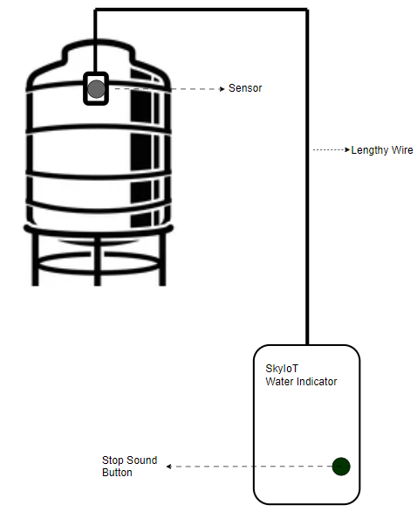

Your need to hang the sensor switch in the water tank, attach it firmly to the tank and then connect thelengthy wire up to the controller using 2 core wire.

Open the back panel of the device and insert the batteries if not available or if you need to replace new batteries. This device used 3 AA batteries.

Note: batteries are already provided with this device

Once the water touches the sensor, the indicator will make beeps for 3 to 4 minutes.

If you want to stop the beep, just press the stop button.

***Testing: for testing, just connect indicator wire and the float sensor switch wire and pull the switch. The device will be instantly active and start beeping.***